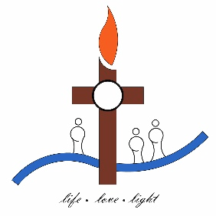
St Gregory’s Parish

47 Lowe St
PO Box 175
Queanbeyan NSW 2620
Phone: (02) 6299 4611
Email: queanbeyan@cg.org.au

REQUEST FOR SACRAMENTAL INFORMATION FROM CHURCH REGISTERS

Only the person directly concerned (ie the baptised person) has the right of access to his or her own record. There are privacy issues determining right of access to church records. Third party access must be determined and in accordance with privacy legislation and Church law appropriate identification must be provided before access to information from Church Sacramental records.

Name of person requesting the information:

Relationship to person you are requesting information of? If the person is under 18 years of age, the parent or legal guardian may obtain information required on behalf of the person.

REASON FOR REQUEST
(ie. Lost copy, school entry, family history)
INFORMATION REQUESTED
Extract of Information from (please tick) | ___ BAPTISM REGISTER  ___ CONFIRMATION REGISTER  ___ MARRIAGE REGISTER  ___ DEATH REGISTER
Name of Person
(and spouse if relevant)
Date of Birth/s

Is the person/s deceased?  (if the baptised person is less that 100 years old ,it must be determined they are not alive to request information personally) | Yes/No  If Yes – proof of death is required if less than 100 years since birth date.  If No - written consent from the person must be obtained. Copy to be forwarded with the application.
Any known information (dates, relationships, places) that may assist in directing our search.

DECLARATION
I have provided the necessary form of identification with my birthdate to the Parish Office. If the request is not for Internal Church purposes, rather for Family History/Genealogy Reasons, I accept that a Search Fee will be charged.

_______________________________ ______________________________ _________
PLEASE PRINT NAME CLEARLY SIGNATURE DATE

